Pass Task 5.1 report

|  |  |
| --- | --- |
| Student Name | Lim Jia Lok |
| Student ID | 101212631 |

## SUB Task 5.1.1

#### Solution

STUDENT Table

|  |  |
| --- | --- |
| Attribute | Data type |
| stud_id | Number (9) |
| stud_name | Varchar (30) |
| stud_phone | Varchar (15) |
| stud_date_of_birth | Date |
| stud_city | Varchar (20) |
| stud_address | Varchar (50) |
| stud_postcode | Varchar (10) |

Grade Table

|  |  |
| --- | --- |
| Attribute | Data type |
| stud_id | Number (9) |
| subj_code | Char (8) |
| semester | Number (1) |
| year | Number (4) |
| grade | Char (2) |

Subject Table

|  |  |
| --- | --- |
| Attribute | Data type |
| subj_code | Char (8) |
| Subj_title | VarChar (50) |

Enrolment Table

|  |  |
| --- | --- |
| Attribute | Data type |
| stud_id | Number (9) |
| subj_code | Char (8) |
| semester | Number (1) |
| year | Number (4) |
| comment | Varchar(max) |

#### Comments/findings

…

(Where applicable)

## SUB Task 5.1.2

#### Solution

|  |  |
| --- | --- |
| Relation | Primary Key |
| Student | stud_id |
| Enrollment | stud_id, subj_id, semester, year |
| Subject | subj_code |
| Grade | stud_id, subj_id, semester, year |

#### Comments/findings

…

(Where applicable)

## SUB Task 5.1.3

#### Solution

|  |  |  |
| --- | --- | --- |
| Relation | Foreign Key | References |
| Enrolment | stud_id | Student.stud_id |
| subj_id | Subject.subj_id |
| Grade | subj_id | Enrollment.subj_id |
| stud_id | Enrollment.stud_id |
| semester | Enrollment.semester |
| year | Enrollment.year |

#### Comments/findings

…

(Where applicable)

## SUB Task 5.1.4

#### Solution

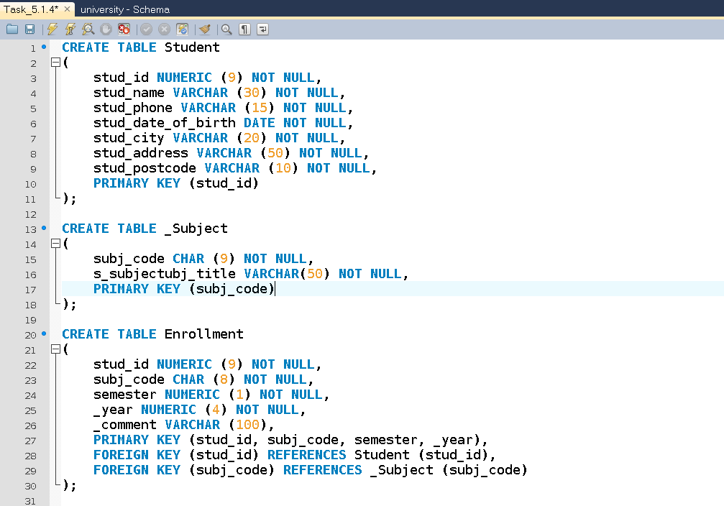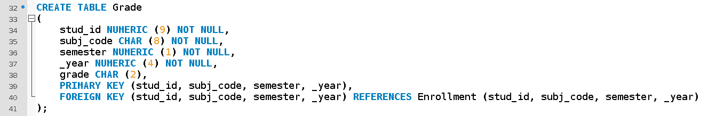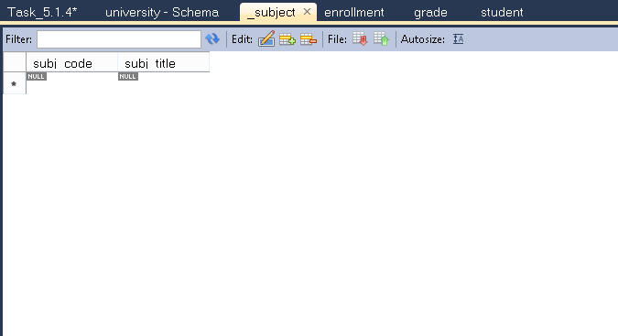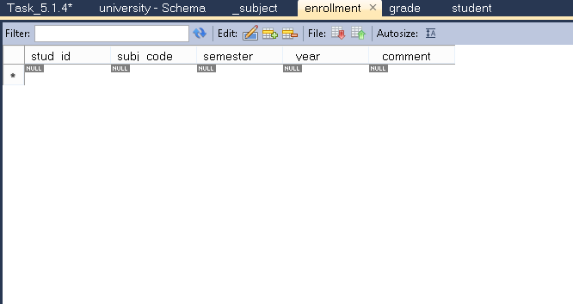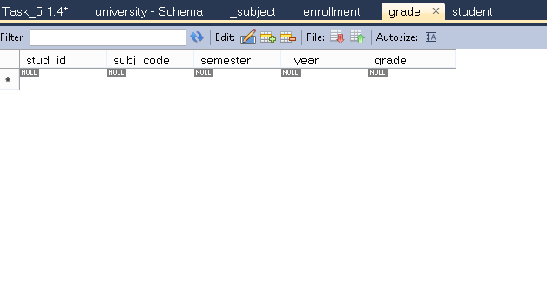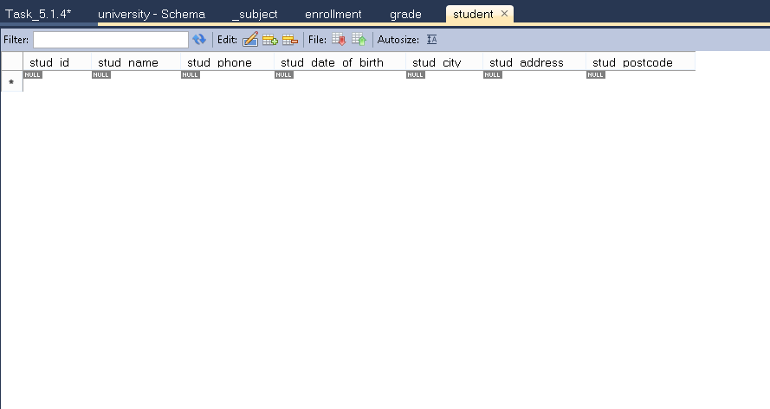

#### Comments/findings

…

(Where applicable)

## SUB Task 5.1.5

#### Solution

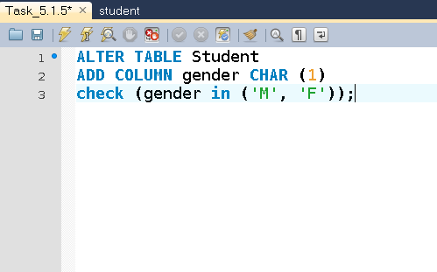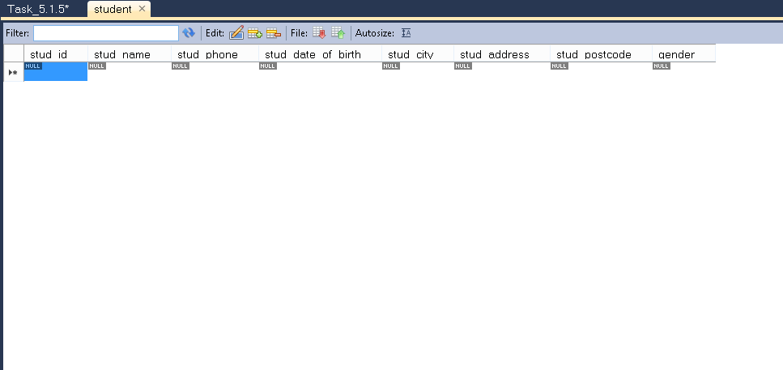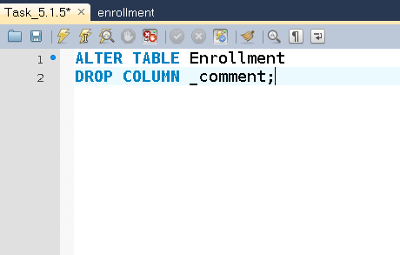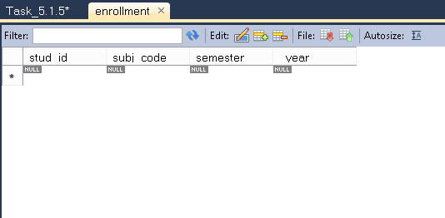

#### Comments/findings

…

(Where applicable)